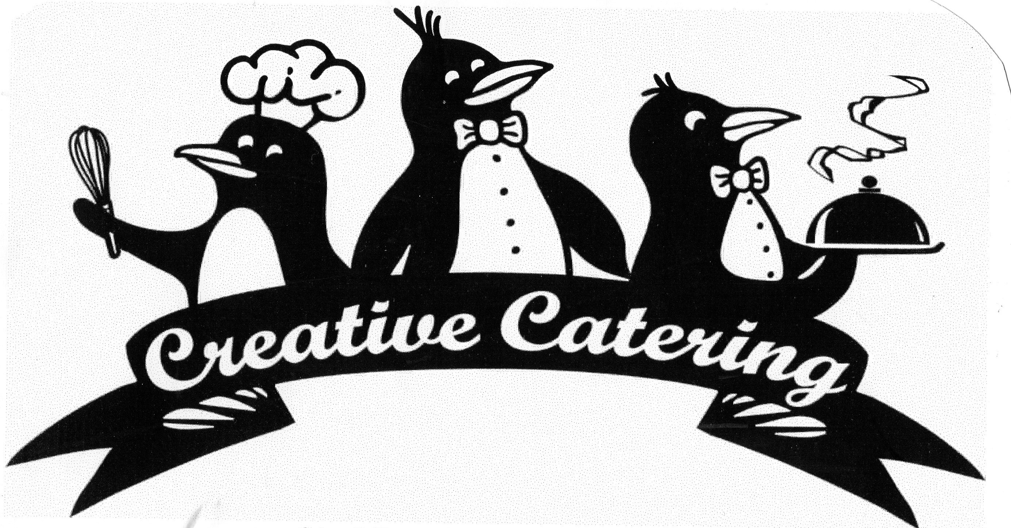

Serving New York since 1988
We are a Full Service Event Company

Ph: (315) 453-5555 www.CreativeCateringCNY.com CreativeCateringCNY@gmail.com

Our Buffet Options

Leafy Greens

CLASSIC CAESAR SALAD  Torn romaine tossed in our Caesar dressing  With Garlic Croutons & Parmesan Cheese  FIELD SALAD  Baby greens, mandarin oranges, seedless red grapes, raisins  & toasted nuts or sunflower seeds, with honey poppy seed dressing  TOSSED SALAD  Torn romaine & iceberg lettuce, ripe tomatoes, cucumbers  red cabbage & carrots  Tossed in Italian Dressing (other dressings available)  ORIENTAL SALAD  Assorted lettuce, red & Napa cabbage, spring onions, green peas  Carrots, toasted sesame seeds & crispy noodles  Dressed with rice wine, ginger, soy & toasted sesame oil vinaigrette  CALIFORNIA SPINACH SALAD (seasonal)  Flat leaf spinach, fresh mushrooms & hard boiled eggs  In our sweet & tangy bacon & Vidalia onion dressing (warm) | GREEK SALAD  Sweet peppers, cucumbers, ripe tomatoes  Red onions & pitted kalamata olives  In our feta cheese, lemon, herb & olive oil vinaigrette  STRAWBERRY FIELDS  Baby greens, fresh strawberries, raisins, toasted walnuts & Gorgonzola  In a honey poppy seed dressing  MESCLUN MIX  Baby greens, roma tomatoes, seedless cucumbers, mozzarella  Roasted peppers & toasted nuts  In a balsamic vinaigrette  THAI HOUSE SALAD  Romaine & Iceberg lettuce, with tomatoes, carrots, onion & cucumber  In our spicy peanut & coconut milk dressing  Topped with roasted peanuts  BLT SALAD  Mixed greens, hard boiled eggs, cherry tomatoes & crispy bacon  Sharp cheddar cheese dressing

Chilled Vegetable Salads

EGGPLANT COMPANATA  Eggplant, sweet peppers, onions & celery  Sautéed with black & green olives and capers  Sweet red wine vinegar reduction  RAITA  Raita is an Indian salad; it is great served with any spicy dish!  Diced tomatoes, cucumber & mint  In a yogurt dressing  ASIAN BROCCOLI SLAW  Fresh shredded broccoli & carrots  With toasted black & white sesame seeds  Tossed in a gingered soy & rice wine vinaigrette  CAPRESE SALAD  Sliced tomatoes, fresh mozzarella, basil & scallions  Drizzled with extra virgin olive oil & balsamic syrup | SOUTH WESTERN BLACK BEAN SALAD  Black beans, fire roasted sweet corn, roasted red peppers & cilantro  Dressed in salsa & lime vinaigrette  FRESH GREEN BEAN SALAD  Fresh green beans & roasted red peppers  Tossed in our red wine vinaigrette  TOMATO & CUCUMBER SALAD  Ripe tomatoes, cucumbers & sliced red onions  In a red wine Italian vinaigrette  PANZANELLA  Roma tomatoes & ciabatta bread salad  Italian flat parsley, fresh basil, hot cherry peppers & sliced lemon  Extra virgin olive oil & red wine vinaigrette

Serving New York since 1988
We are a Full Service Event Company

Ph: (315) 453-5555 www.CreativeCateringCNY.com CreativeCateringCNY@gmail.com

Chilled Salads (starch)
GREEK PASTA SALAD  Penne rigati with spinach, bell peppers  Cucumbers diced tomatoes, red onion & kalamata olives  Feta, lemon, herb & olive oil vinaigrette  TUSCAN PASTA SALAD  Al dente pasta, balsamic marinated grilled eggplant, zucchini  Vidalia onions, mushrooms & bell peppers  COUNTRY POTATO SALAD  New skin potatoes, hard boiled eggs, celery  Sweet relish, Hellmann’s mayonnaise & a touch of mustard  PESTO NEW POTATOES  New potatoes tossed with fresh basil, pine nuts, roasted garlic  Asiago & extra virgin olive oil | CLASSIC ITALIAN PASTA SALAD (vegetarian)  Tri colored spirals, carrots, celery, broccoli, red onion  Black olives & pecorino romano in a zesty Italian dressing  THAI PEANUT NOODLES  Noodles & sweet peppers  Tossed in our spicy peanut dressing  CASHEW NOODLES  Noodles, snow peas & red bell peppers  TABOULI  This is a Lebanese salad that can be served with anything!  Cracked bulgur wheat, tomatoes, cucumber, onions, mint,  Lemon juice & olive oil  JAPANESE RICE SALAD  Sticky short grain rice, pickled & fresh ginger, sliced scallion  Wasabi soy rice wine vinaigrette

Sweet Chilled
GOLDEN PINEAPPLE & FRESH STRAWBERRIES (seasonal)  With "Baileys" Irish Chocolate Fondue  CARAMEL APPLE SALAD  New York Granny Smith & Empire Apples & Mini Marshmallows  Tossed with our homemade butterscotch caramel  Topped with broken pretzels  AMBROSIA  Mandarin oranges, shredded coconut & maraschino cherries  Tossed with a whipped vanilla mousse  HOUPIA  Homemade Hawaiian fluffy coconut whip  Coconut milk, cream of coconut, fresh coconut & whipped cream  Topped with toasted coconut | PINEAPPLE PISTACHIO FLUFF  BLUEBERRY CAVIAR (seasonal)  Fresh blueberries in a sweet strawberry cream cheese  FRESH FRUIT SALAD  Golden pineapple, berries, cantaloupe, honeydew  & seedless grapes  RIPE MELONS (seasonal)  Honey dew, cantaloupe & watermelon  FRESH FRUIT DISPLAY  Golden pineapple boats, strawberries, kiwi  Cantaloupe, honeydew  Red & green seedless grapes

Vegetables
CUT CORN IN MAPLE BUTTER  BROCCOLI IN LEMON BUTTER  BROCCOLI  With kalamata olives  Toasted pinenuts & chevre | CAJUN CORN  With caramelized Vidalia & Red Bells  VEGGIES VERDE  Broccoli, peas, zucchini & sugar snaps  FRESH GREEN BEANS ALMONDINE  GREEN BEANS & ROASTED PEPPERS  With Olive Oil & Garlic | ROASTED ROOT VEGETABLES  Carrots, parsnips & Brussel sprouts  HONEY & BRANDY GLAZED CARROTS  BABY CARROTS, BROCCOLI & CAULIFLOWER  In herb butter

Serving New York since 1988
We are a Full Service Event Company

Ph: (315) 453-5555 www.CreativeCateringCNY.com CreativeCateringCNY@gmail.com

Hot Sides (starch)
RED BEANS & RICE (can be made vegetarian)  SWEET POTATOES (yams)  With cinnamon brown sugar honey butter  BAKED POTATOES  With cheddar, bacon & scallion sour cream (served on the side)  GARLIC BASIL NEW POTATOES  SOUR CREAM & SCALLION SMASHED POTATOES  HOMEMADE GERMAN POTATO SALAD  Fresh sliced new potatoes, tossed with our home made  Sweet & tangy bacon & Vidalia onions  Garnished with chopped flat parsley  GRANDMA’S MAC - n - CHEESE  Creamy with NY Sharp Cheddar & French Fried Onion Crust  FIRE ROASTED CORN & WHITE BEAN SUCCOTASH  Fire roasted sweet corn, white beans  Caramelized onions, red & orange bell peppers | RICE PILAF  With celery, onions, peppers, mushrooms & peas  In chicken or vegetable stock  PASTA WITH TWIN PESTOS  Basil & Pine nuts & Sundried Tomato & Roasted Garlic  BAKED PENNE RIGATI  In a tomato basil sauce, topped with mozzarella  PENNE IN A PINK VODKA SAUCE  Penne in a tomato, cream and vodka sauce  CHEESE TORTELLINI  With roasted pepper crème fraiche  STUFFED SHELLS FLORENTINE  Stuffed shells on a bed of sautéed spinach in our tomato basil sauce  Topped with mozzarella & parmesan cheese  OR Pink Vodka Sauce  UTICA GREENS  Fresh greens sautéed with garlic, hot peppers and prosciutto  Topped with pecorino Romano and seasoned breadcrumbs
Entrées
LASAGNA (Vegetarian)  EGGPLANT PARMESAN  FETTUCINE RONALDO  Chicken Breast or Shrimp, roasted peppers, sweet peas & mushrooms  In a sherried cream sauce  CHICKEN RIGGIES  Sautéed chicken breast, bell pepper, hot cherry peppers & Vidalia onions  In a creamy tomato & parmesan sauce  CHICKEN CZARINA  Sautéed chicken breast in a light parmesan cream sauce  Garnished with baby shrimp & julienne vegetables  CHICKEN MARSALA  Sautéed chicken breast in a Marsala wine sauce  With fresh mushrooms  CHICKEN VERONIQUE  Sautéed chicken breast in a light white wine sauce  Garnished with seedless red grapes  ROASTED TURKEY  With Cranberry Chutney  SPIRAL BAKED HAM  With Honey Mustard  CILANTRO & CITRUS MARINATED SALMON  APPLEWOOD SMOKED SALMON  With Cucumber Salsa | HONEY MUSTARD GLAZED CHICKEN BREAST  CHICKEN BREAST VINO BIANCO  With dry vermouth & mushrooms  ITALIAN CHICKEN BREAST  With fresh basil & diced tomatoes  CHICKEN PICCATA  Sautéed chicken breast topped with a lemon caper sauce  GRILLED TERIYAKI CHICKEN BREAST  With pineapple  BEER CAN CHICKEN (bone in)  SLICED ROAST BEEF AU JUS  With English Horseradish Sauce  CIDER BAKED PORK LOIN  With caramelized Vidalia’s & apples  GIANELLI HOT ITALIAN SAUSAGE (Pork or Turkey)  With sautéed fresh red, yellow & green peppers & Vidalia onions  PEPPERED ROAST ANGUS SIRLOIN  Our most popular  PEPPERED BEEF TENDERLOIN  (Filet Mignon ~ leanest and most tender)  SLOW ROASTED ANGUS PRIME RIB  Specialty Trimmed, Star Fat Removed  Best flavor, highly marbled, very tender

